EXPENSE TRACER

PROJECT REPORT ON
EXPENSE TRACER
SUBMITTED TO

MACIT SEM - 2
PREPARED BY
Chirag J Thanki
GUIDED BY

Mr.
Nirav dattani

A PROJECT REPORT ON
ONLINE FOOD SERVICES SYSTEM

Submitted By
Thanki Chirag Jitendrakumar
(Enroll No.: R24014201004963210031)
Guided By: Dr. Jyotsna Salet
In fulfillment for the award of the degree
of
Master of Science in Information Technology
In
Computer Department
Shri V. J. Modha College of I.T, Porbandar
Bhakt Kavi Narsinh Mehta University, Junagadh
March 2025



Acknowledgement
• I am sincerely grateful to all those who contributed towards the completion of this Online Food Services System project developed using PHP programming, MySQL database, HTML, CSS, JS and framework like Bootstrap. This project would not have been possible without the guidance and support of many individuals.
• First and foremost, I would like to thank Dr. Jyotsna Salet for his invaluable guidance, insightful feedback, and constant encouragement throughout the course of this project. Their expertise and suggestions were instrumental in the successful implementation of this system.
• I would also like to express my gratitude to my peers and fellow classmates who provided constructive feedback and motivation during challenging times. Their input was vital in refining the project's features and improving its functionality.
• It is my great pleasure to represent my project as one web application titled “Online Food Services System” and which done in semester-1 of MSc I.T., affiliated to BKNMU (Bhakta Kavi Narsinh Mehta University).
• Additionally, I am thankful for the availability of various online resources and forums that offered technical insights and solutions to the issues I encountered during the development process.
• Lastly, I would like to extend my appreciation to my family for their unwavering support and understanding while I dedicated time to this project. Their encouragement helped me stay focused and motivated.

PREFACE

This desktop application provides facilities like:

  - Login to user
  - Login to Admin
  - Manage food dishes
  - Manage food order
  - Manage restaurants
  - Update order
  - Inform user

- This system is made using MySQL Database for storing data and HTML, CSS, JS, for front-end part (client-side) and PHP for back-end (server-side).
- I used XAMPP for server access.
- This system has only access right to Admin.

INDEX

Sr. No. | Topic Name | Page No.
Chapter – 1 | INTRODUCTION  - Purpose  - Scope  - Technology and Literature Review | 5
Chapter – 2 | SYSTEM ANALYSIS  - Problem Definition  - Process Model  - Grant Chart | 9
Chapter – 3 | SYSTEM DIRGRAM  - Data Flow Diagram  - E-R Diagram  - Use Case Diagram | 13
Chapter – 4 | DATA DICTIONARY  4.1 Data Dictionary | 17
Chapter – 5 | INPUT AND OUTPUT DESIGN  5.1 Admin Layout | 20
Chapter – 6 | IMITATIONS AND FUTURE ENHANCEMENT  - Limitations  - Future Enhancement | 51
Chapter – 7 | CONCLUSION  - Conclusion  - Advantages | 56
Chapter – 8 | BIBILIOGRAPHY  8.1 Bibliography | 58
Chapter – 9 | REFERENCES  9.1 Reference | 60

  - Chapter -1 INTRODUCTION
  - 1.1 Purpose
  - 1.2 Scope
  - 1.3 Technology and Literature Review

EXPENSE TRACER

PREFACE

As a student Off MSCIT (Semester - 2) according to the syllabus subscribed by the Bhakt Kavi Narsinh Mehta University, Junagadh (Gujarat) to prepare a project on any Particular subject of Students choice. The project should be selected on precise subject that will fulfill the requirements.
The main objective of the project is to develop awareness regarding application of theories in the Modern World of Information Technology.
We have taken almost care that the information provided in the project is true and Project is in a smooth-running condition and Error free. We sincerely apologies if any wrong information is given, we have tried our level best to provide all the necessary information as per the syllabus.

EXPENSE TRACER

ACKNOWLEDGEMENT

It is our great pleasure to present this report of “EXPENSE TRACER APP” though the preparation of this report is our own work. We have received help from many persons & our professors. We have also very thankful to all those persons who helped in carrying out this work.
We sincerely express our heartiest thanks to our Project guide Mr. Nirav Dattani for his valuable guidance as we have collected all the necessary information easily because of these few people & for this we would like to express our appreciation & grateful towards all those individuals who have contributed in own-way or other. Their efforts & valuable time in guiding our group. We humble to submit our project report here with lots of hopes before you.
Again, we are also thankful to all those who helped in preparation of this report knowingly, directly & indirectly.

Project by

Chirag J Thanki

EXPENSE TRACER

INDEX

Sr. No. | TITLE | PAGE NO.
1 | Project Profile | 5
2 | Preliminary Investigation | 6
3 | Requirement Analysis | 8
4 | Use Case Diagram | 9
5 | Entity Relationship Diagram | 10
6 | Activity Diagram | 11
7 | Class Diagram | 12
8 | Database Creation | 13
9 | User Interface and Source Code | 15
10 | References | 46

EXPENSE TRACER

PROJECT PROFILE

Project Title | : | Expense Tracer App
Developed At | : | Dr,VGIT , College, Porbandar.
Developed By | : | - Shivani bapodra  - Parth tanna
Project Guide | : | Mr. Nirav Dattani
Front End | : | Android Studio
Back End | : | SQLite 3
Client-side Runtime | : | Android Device (Minimum API - 22)

EXPENSE TRACER

FEASIBILITY STUDY (PRELIMINARY INVESTIGATION)

Expense tracer is complete app to track your all the expenses bared by your pocket or bared by you & manage your personal finance.

So that you can trace where your money goes as well as from where money comes in, you can limit & plan accordingly.

Also features like Income/Expense, keep tracking of your incoming & outgoing flows, Bills maintain your recurring expenses & keep reminding you as your helping hand. Over all a powerful personal finance tool that keeps on improving your productivity, saves a time & helps you to save your money.

In the following, we describe the key aspects of the feasibility analysis:

- Technical Feasibility
- Economic Feasibility
- Operational Feasibility
- Schedule Feasibility

Technical Feasibility

Technical feasibility means whether the project is working in a perfect manner. It means the project must support or perform all the technical functions for which it is implemented. The Project “Expense Tracer App” through android is technically feasible. This System is well capable of interface thus project is able to work in effective and efficient manner.

Economic Feasibility

A systems request is economically feasible if the projected benefits of the proposed system outweigh the estimated costs involved in developing (or purchasing), installing, and operating it.

Economic feasibility is a term which is related to estimation of cost required for the project is feasible under the economic condition. There is no cost to maintain this app

Operational Feasibility

Operational Feasibility means the project must perform its operations perfectly. If the project is working properly than we can say that the project has operational feasibility.
Operational feasibility measures the suitability of the proposed system with regard to human factors.
It is an assessment of the acceptance (or rejection) of the system by the people within the organization.

Scheduling Feasibility

- Scheduling is all based upon time; it measures whether there is available time to do the project.

- Some projects are needed to be completed in the given deadlines; feasibility determines whether the project can be completed within that deadline.

- This feasibility is used to allocate time for separate module development in proposed system.

EXPENSE TRACER

REQUIREMENT ANALYSIS

Requirement Analysis, also known as Requirement Engineering, is the process of defining user expectations for a new Application being built or modified. Requirements analysis encompasses those tasks that go into determining the needs or conditions to meet for a new or altered product or project.

Non – Functional Requirements-

The Non-Functional Requirements this section will describe the hardware and software requirement which is at least needed to run this android application.

Hardware Requirement –

  - Processor: The minimum requirement of processor is at least Quad-core 1.2 GHz Cortex-A53 or better with 2 GHz processing speed. The speed of processor determines the time taken for the execution of the system. Higher processing speed leads to faster execution of the system.
  - RAM: There should be minimum 2 GB of RAM available for the smooth functioning of the project. Higher memory leads in better results.
  - Internal Storage: There should be about minimum 8GB of Internal Storage for smooth functioning of the project and more depends on Users data usages.

Software Requirement

Operating System: Android 6.0 (Marshmallow) or above versions.

Functional Requirements

The Functional Requirements in this we will see the required modules for the proposed system.
- Add / Remove / Select Categories and Expenses
- View Expense Report
- change settings

EXPENSE TRACER

USECASE DIAGRAM

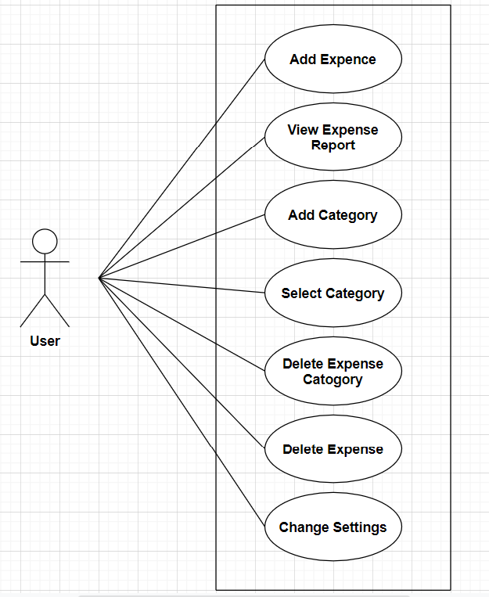
A use case diagram is a simplest representation of a user's interaction with the system that shows the relationship between the user and the different use cases in which the user is involved.

EXPENSE TRACER

E-R DIAGRAM

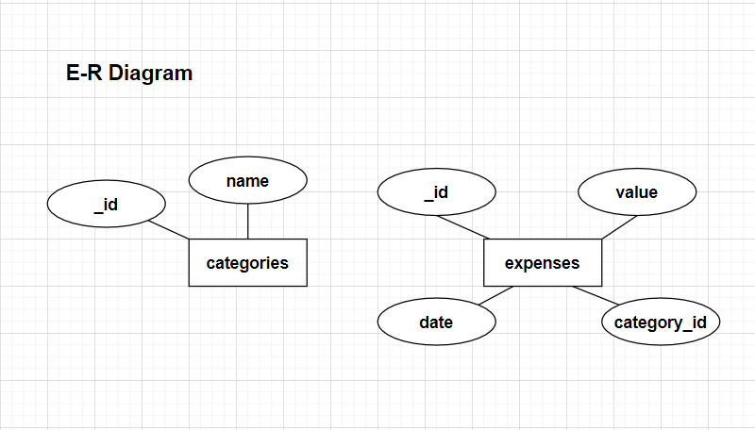
An entity-relationship diagram - otherwise known as an ERD - is a data modeling technique that creates an illustration of an information system's entities and the relationships between those entities.

EXPENSE TRACER

ACTIVITY DIAGRAM

Activity diagrams, which are related to program flow plans (flowcharts).
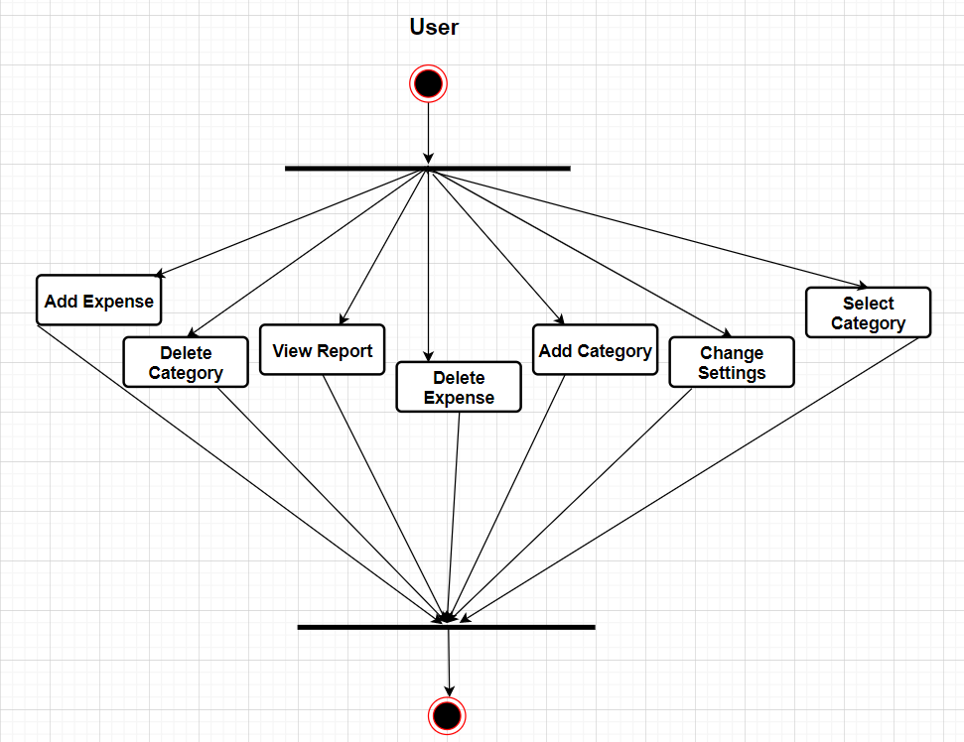

EXPENSE TRACER

CLASS DIAGRAM

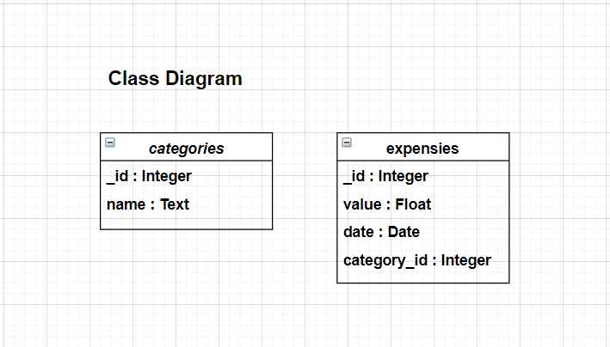
The class diagram is a static diagram. It represents the static view of an application.

The class diagram describes the attributes and operations of a class and also the constraints imposed on the system.

The class diagram shows a collection of classes, interfaces, associations, collaborations and constraints. It is also known as a structural diagram.

EXPENSE TRACER

DATABASE CREATION

Normalization of Tables:

Normalization is the process of organizing data in a database. This includes creating tables and establishing relationships between those tables according to rules designed both to protect the data and to make the database more flexible by eliminating redundancy and inconsistent dependency.

Data Dictionary

One of the requirements in the development of the DFD is precise naming of the components. This is critical for the data oriental components namely the data flow and the data stores. So, it is necessary to develop data dictionary.
In a data dictionary data store and data flow describe in terms of data element and data structures. A data element is basic unit of data that can be assigned a meaningful data.
Data structures are made up of data element and other sub data structures.

Database Name: expense_tracer.db

Table 1: categories

Sr No. | Fields | Datatype
1 | _id | Integer
2 | name | Text

EXPENSE TRACER

Table 2: expenses

Sr No. | Fields | Datatype
1 | _id | Integer
2 | value | Float
3 | date | Date
4 | category_id | Integer

EXPENSE TRACER

USER INTERFACE AND SOURCE CODE

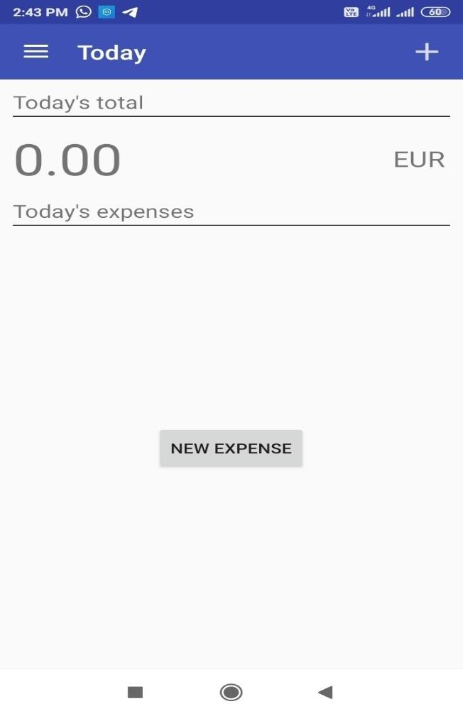

Activity_main.xml

<?xml version="1.0" encoding="utf-8"?>
<RelativeLayout xmlns:android="http://schemas.android.com/apk/res/android" xmlns:app="http://schemas.android.com/apk/res-auto" android:id="@+id/top_parent"
android:layout_width="match_parent" android:layout_height="match_parent" android:fitsSystemWindows="true">

<!-- The ActionBar (Toolbar) displayed at the top -->

<include

EXPENSE TRACER

android:id="@+id/toolbar" layout="@layout/toolbar" />

<android.support.v4.widget.DrawerLayout android:id="@+id/drawer_layout" android:layout_width="match_parent" android:layout_height="match_parent" android:layout_below="@id/toolbar">

<!-- The main content view where fragments are loaded -->

<FrameLayout android:id="@+id/content_frame" android:layout_width="match_parent" android:layout_height="match_parent" />

<android.support.design.widget.NavigationView android:id="@+id/nav_drawer" android:layout_width="wrap_content" android:layout_height="match_parent" android:layout_gravity="start" android:background="@android:color/white" app:menu="@menu/drawer_view"/>

</android.support.v4.widget.DrawerLayout>

</RelativeLayout>

MainActivity.java

package com.github.ematiyuk.expensetracer.activities;
import android.content.Intent;
import android.content.res.Configuration;
import android.os.Bundle;
import android.support.annotation.IdRes; import android.support.annotation.LayoutRes; import android.support.annotation.Nullable;
import android.support.design.widget.NavigationView;
import android.support.v4.app.Fragment;
import android.support.v4.view.GravityCompat;
import android.support.v4.widget.DrawerLayout; import android.support.v7.app.ActionBarDrawerToggle; import android.view.MenuItem;

EXPENSE TRACER

import com.github.ematiyuk.expensetracer.fragments.CategoryFragment;
import com.github.ematiyuk.expensetracer.R;
import com.github.ematiyuk.expensetracer.fragments.ReportFragment;
import com.github.ematiyuk.expensetracer.fragments.TodayFragment;


public class MainActivity extends BaseFragmentActivity {
private DrawerLayout mDrawerLayout; private NavigationView mNavDrawer;
private ActionBarDrawerToggle mDrawerToggle;

@Override @LayoutRes
protected int getLayoutResId() {
return R.layout.activity_main;
}

@Override
protected void onCreate(Bundle savedInstanceState) {
super.onCreate(savedInstanceState);

mDrawerLayout = (DrawerLayout) findViewById(R.id.drawer_layout); mNavDrawer = (NavigationView) findViewById(R.id.nav_drawer); mDrawerToggle = setupDrawerToggle();

// Tie DrawerLayout events to the ActionBarToggle
mDrawerLayout.addDrawerListener(mDrawerToggle);

// Setup drawer view
setupDrawerContent(mNavDrawer);

// Select TodayFragment on app start by default
loadTodayFragment();
}

@Override
protected void onPause() { super.onPause(); closeNavigationDrawer();
}

@Override

EXPENSE TRACER

public boolean onOptionsItemSelected(MenuItem item) {
// Pass the event to ActionBarDrawerToggle, if it returns
// true, then it has handled the app icon touch event
if (mDrawerToggle.onOptionsItemSelected(item)) {

return true;

}

return super.onOptionsItemSelected(item);
}

@Override
protected void onPostCreate(@Nullable Bundle savedInstanceState) {
super.onPostCreate(savedInstanceState);
// Sync the toggle state after onRestoreInstanceState has occurred.
mDrawerToggle.syncState();
}

@Override
public void onConfigurationChanged(Configuration newConfig) {
super.onConfigurationChanged(newConfig);
// Pass any configuration change to the drawer toggle
mDrawerToggle.onConfigurationChanged(newConfig);
}

@Override
public void onBackPressed() {
if (!closeNavigationDrawer()) {
Fragment currentFragment = getSupportFragmentManager()
.findFragmentById(R.id.content_frame);
if (!(currentFragment instanceof TodayFragment)) { loadTodayFragment();
} else {
// If current fragment is TodayFragment then exit
super.onBackPressed();
}
}
}

private ActionBarDrawerToggle setupDrawerToggle() {
return new ActionBarDrawerToggle(this, mDrawerLayout, mToolbar, R.string.drawer_open, R.string.drawer_close);

EXPENSE TRACER

}

private void setupDrawerContent(NavigationView navigationView) { navigationView.setNavigationItemSelectedListener(

new NavigationView.OnNavigationItemSelectedListener() { @Override
public boolean onNavigationItemSelected(MenuItem menuItem) { selectDrawerItem(menuItem);

return true;
}
});
}

private void selectDrawerItem(MenuItem menuItem) { closeNavigationDrawer(); switch(menuItem.getItemId()) {
case R.id.nav_today:
loadFragment(TodayFragment.class, menuItem.getItemId(), menuItem.getTitle());

break;
case R.id.nav_report:
loadFragment(ReportFragment.class, menuItem.getItemId(), menuItem.getTitle());

break;
case R.id.nav_categories:
loadFragment(CategoryFragment.class, menuItem.getItemId(), menuItem.getTitle());

break;
case R.id.nav_settings:
startActivity(new Intent(MainActivity.this, SettingsActivity.class));

break; default:
loadFragment(TodayFragment.class, menuItem.getItemId(), menuItem.getTitle());
}
}

private boolean closeNavigationDrawer() {
boolean drawerIsOpen = mDrawerLayout.isDrawerOpen(GravityCompat.START); if (drawerIsOpen) {
mDrawerLayout.closeDrawer(GravityCompat.START);
}
return drawerIsOpen;
}

EXPENSE TRACER

public void hideNavigationBar() { closeNavigationDrawer();
}
private void loadFragment(Class fragmentClass, @IdRes int navDrawerCheckedItemId, CharSequence toolbarTitle) {
Fragment fragment = null; try {
fragment = (Fragment) fragmentClass.newInstance();
} catch (Exception e) { e.printStackTrace();
}

insertFragment(fragment);

// Highlight the selected item
mNavDrawer.setCheckedItem(navDrawerCheckedItemId);
// Set action bar title
setTitle(toolbarTitle);
}

private void loadTodayFragment() { loadFragment(TodayFragment.class, R.id.nav_today,
getResources().getString(R.string.nav_today));
}
}

EXPENSE TRACER

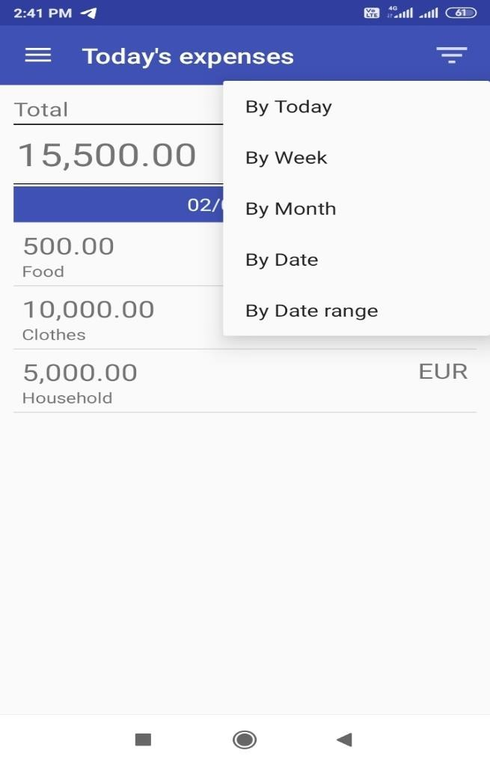

Fragment_report.xml

<LinearLayout xmlns:android="http://schemas.android.com/apk/res/android" android:layout_width="match_parent" android:layout_height="match_parent"

android:orientation="vertical">

<LinearLayout android:layout_width="match_parent" android:layout_height="wrap_content" android:orientation="vertical" android:layout_weight="0">

<LinearLayout

EXPENSE TRACER


android:layout_width="match_parent" android:layout_height="wrap_content" android:orientation="vertical" android:layout_marginTop="10dp" android:layout_marginLeft="10dp" android:layout_marginRight="10dp" android:layout_marginBottom="0dp">

<TextView android:layout_width="match_parent" android:layout_height="wrap_content" android:layout_marginBottom="2dp" android:textSize="18sp" android:text="@string/total_string" />

<View

android:layout_width="match_parent" android:layout_height="1dip" android:background="#000000" />

</LinearLayout>

<RelativeLayout android:layout_width="match_parent" android:layout_height="wrap_content" android:layout_marginTop="0dp" android:layout_marginBottom="0dp" android:layout_marginLeft="10dp" android:layout_marginRight="10dp">

<TextView android:id="@+id/expenses_report_total_text_view" android:layout_width="wrap_content" android:layout_height="55dp" android:gravity="start|center_vertical" android:paddingRight="4dp" android:paddingEnd="4dp" android:paddingLeft="2dp" android:paddingStart="2dp" android:textSize="30sp" android:singleLine="true"/>

EXPENSE TRACER


<TextView android:id="@+id/expenses_report_total_currency_text_view" android:layout_width="wrap_content" android:layout_height="55dp" android:layout_toEndOf="@id/expenses_report_total_text_view" android:layout_toRightOf="@id/expenses_report_total_text_view" android:gravity="end|center_vertical" android:paddingRight="4dp"
android:paddingEnd="4dp" android:paddingLeft="0dp" android:paddingStart="0dp" android:textSize="22sp" android:singleLine="true" android:layout_alignParentEnd="true" android:layout_alignParentRight="true"/>

</RelativeLayout>

<LinearLayout android:layout_width="match_parent" android:layout_height="wrap_content" android:orientation="vertical" android:layout_marginTop="0dp" android:layout_marginLeft="10dp" android:layout_marginRight="10dp" android:layout_marginBottom="2dp">

<View
android:layout_width="match_parent" android:layout_height="1dip" android:background="#000000" />

</LinearLayout>

</LinearLayout>

<LinearLayout android:layout_width="match_parent" android:layout_height="0dp" android:orientation="vertical"

EXPENSE TRACER

android:layout_marginLeft="10dp" android:layout_marginRight="10dp" android:layout_weight="1">


<LinearLayout android:id="@+id/expenses_report_progress_bar" android:layout_width="match_parent" android:layout_height="match_parent" android:layout_gravity="center" android:gravity="center">

<ProgressBar style="@style/Base.Widget.AppCompat.ProgressBar" android:layout_width="wrap_content" android:layout_height="wrap_content" android:indeterminate="true"/>

</LinearLayout>

<ListView android:id="@+id/expenses_report_list_view" android:layout_width="match_parent" android:layout_height="match_parent"/>

<LinearLayout android:id="@+id/expenses_report_empty_list_view" android:layout_width="match_parent" android:layout_height="match_parent" android:orientation="vertical" android:gravity="center">

<TextView android:id="@+id/expenses_report_empty_list_text_view" android:layout_width="wrap_content" android:layout_height="wrap_content" android:textSize="20sp" android:text="@string/no_expenses"/>

</LinearLayout>

EXPENSE TRACER

</LinearLayout>

</LinearLayout>

  - ReportFragment.java

package com.github.ematiyuk.expensetracer.fragments;

import android.app.DatePickerDialog; import android.content.SharedPreferences; import android.database.Cursor;
import android.net.Uri;
import android.os.Bundle;
import android.preference.PreferenceManager; import android.support.annotation.Nullable; import android.support.v4.app.Fragment; import android.support.v4.app.LoaderManager;
import android.support.v4.content.CursorLoader; import android.support.v4.content.Loader; import android.support.v7.widget.PopupMenu; import android.view.LayoutInflater;
import android.view.Menu; import android.view.MenuInflater; import android.view.MenuItem; import android.view.View; import android.view.ViewGroup; import android.widget.DatePicker; import android.widget.ListView; import android.widget.TextView;

import com.github.ematiyuk.expensetracer.R;
import com.github.ematiyuk.expensetracer.activities.MainActivity;
import com.github.ematiyuk.expensetracer.adapters.SectionExpenseAdapter; import com.github.ematiyuk.expensetracer.providers.ExpensesContract.Expenses; import
com.github.ematiyuk.expensetracer.providers.ExpensesContract.ExpensesWithCategories;
import com.github.ematiyuk.expensetracer.utils.Utils;

import java.util.Calendar;
import java.util.Date;

EXPENSE TRACER

public class ReportFragment extends Fragment implements
LoaderManager.LoaderCallbacks<Cursor>, PopupMenu.OnMenuItemClickListener {
private static final int SUM_LOADER_ID = 0;
private static final int LIST_LOADER_ID = 1;


private static final String REPORT_TYPE = "report_type"; private static final String SELECTION_ARGS = "selection_args"; private static final int DATE_REPORT = 10;
private static final int DATE_RANGE_REPORT = 11;

private ListView mExpensesListView; private SectionExpenseAdapter mAdapter; private View mProgressBar;
private TextView mTotalValueTextView; private TextView mTotalCurrencyTextView;

@Override
public void onCreate(@Nullable Bundle savedInstanceState) { super.onCreate(savedInstanceState); setHasOptionsMenu(true);
}

@Override
public View onCreateView(LayoutInflater inflater, ViewGroup container, Bundle savedInstanceState) {
// Inflate the layout for this fragment
View rootView = inflater.inflate(R.layout.fragment_report, container, false);

mExpensesListView = (ListView) rootView.findViewById(R.id.expenses_report_list_view);
mProgressBar = rootView.findViewById(R.id.expenses_report_progress_bar);
mTotalValueTextView = (TextView) rootView.findViewById(R.id.expenses_report_total_text_view);
mTotalCurrencyTextView = (TextView) rootView.findViewById(R.id.expenses_report_total_currency_text_view);

mExpensesListView.setEmptyView(rootView.findViewById(R.id.expenses_report_empty_list
_view));
mTotalValueTextView.setText(Utils.formatToCurrency(0.0f));

EXPENSE TRACER

return rootView;
}

@Override

public void onActivityCreated(@Nullable Bundle savedInstanceState) {
super.onActivityCreated(savedInstanceState);

mAdapter = new SectionExpenseAdapter(getActivity());
mExpensesListView.setAdapter(mAdapter);

initLoaders();
}

@Override
public void onResume() { super.onResume(); reloadReportData(); reloadSharedPreferences();
}

@Override
public void onCreateOptionsMenu(Menu menu, MenuInflater inflater) { super.onCreateOptionsMenu(menu, inflater); inflater.inflate(R.menu.fragment_report, menu);
}

@Override
public boolean onOptionsItemSelected(MenuItem item) {
switch (item.getItemId()) {
case R.id.filter_expenses_menu_item: View menuItemView =
getActivity().findViewById(R.id.filter_expenses_menu_item); showPopupMenu(menuItemView);

return true; default:
return super.onOptionsItemSelected(item);
}
}

public void showPopupMenu(View v) {

EXPENSE TRACER

PopupMenu popup = new PopupMenu(getActivity(), v); popup.setOnMenuItemClickListener(ReportFragment.this);


MenuInflater inflater = popup.getMenuInflater(); inflater.inflate(R.menu.report_filter_popup, popup.getMenu()); popup.show();
}

/* from PopupMenu.OnMenuItemClickListener */
@Override
public boolean onMenuItemClick(MenuItem item) { ((MainActivity) getActivity()).hideNavigationBar(); switch (item.getItemId()) {
case R.id.today_filter_option: makeTodaysReport(); return true;
case R.id.week_filter_option: makeWeeklyReport(); return true;
case R.id.month_filter_option: makeMonthlyReport(); return true;
case R.id.date_filter_option: makeDateReport(); return true;
case R.id.range_filter_option: makeDateRangeReport(); return true;

default:
return false;
}
}

@Override
public Loader<Cursor> onCreateLoader(int id, Bundle args) {
int reportType = args.getInt(REPORT_TYPE);
String[] selectionArgs = args.getStringArray(SELECTION_ARGS); Uri uri = null;
switch (id) {
case SUM_LOADER_ID:
if (reportType == DATE_REPORT) {

EXPENSE TRACER

uri = ExpensesWithCategories.SUM_DATE_CONTENT_URI;
} else if (reportType == DATE_RANGE_REPORT) {
uri = ExpensesWithCategories.SUM_DATE_RANGE_CONTENT_URI;
}

break;

case LIST_LOADER_ID: mProgressBar.setVisibility(View.VISIBLE); if (reportType == DATE_REPORT) {
uri = ExpensesWithCategories.DATE_CONTENT_URI;
} else if (reportType == DATE_RANGE_REPORT) {
uri = ExpensesWithCategories.DATE_RANGE_CONTENT_URI;
}

break;
}

return new CursorLoader(getActivity(), uri,
null, null,
selectionArgs,

null
);
}

@Override
public void onLoadFinished(Loader<Cursor> loader, Cursor data) {
switch (loader.getId()) {
case SUM_LOADER_ID:
int valueSumIndex = data.getColumnIndex(Expenses.VALUES_SUM); data.moveToFirst();
float valueSum = data.getFloat(valueSumIndex); mTotalValueTextView.setText(Utils.formatToCurrency(valueSum)); break;

case LIST_LOADER_ID:
// Hide the progress bar
mProgressBar.setVisibility(View.GONE);
// Update adapter's data mAdapter.swapCursor(data); break;
}

EXPENSE TRACER

}

@Override
public void onLoaderReset(Loader<Cursor> loader) {
mAdapter.swapCursor(null);

}

private void reloadSharedPreferences() { SharedPreferences sharedPref =
PreferenceManager.getDefaultSharedPreferences(getActivity());
String prefCurrency = sharedPref.getString(SettingsFragment.KEY_PREF_CURRENCY,
"");

mTotalCurrencyTextView.setText(prefCurrency); mAdapter.setCurrency(prefCurrency);
}

private void reloadReportData() {
// Show the progress bar
mProgressBar.setVisibility(View.VISIBLE);
// Today's report by default
makeTodaysReport();
}

private void makeTodaysReport() {
String today = Utils.getDateString(new Date()); getActivity().setTitle(getString(R.string.filter_todays_expenses));

String[] selectionArgs = { today };

restartLoaders(DATE_REPORT, selectionArgs);
}

private void makeWeeklyReport() {
Calendar calendar = Calendar.getInstance(); Date todayDate = new Date(); calendar.setTime(todayDate); // Set today
calendar.add(Calendar.DAY_OF_YEAR, -7); // Subtract 7 days from today
String startDate = Utils.getDateString(calendar.getTime()); String endDate = Utils.getDateString(todayDate);

EXPENSE TRACER

getActivity().setTitle(getString(R.string.filter_weeks_expenses)); String[] selectionArgs = { startDate, endDate };
restartLoaders(DATE_RANGE_REPORT, selectionArgs);

}

private void makeMonthlyReport() { Calendar calendar = Calendar.getInstance();
calendar.set(Calendar.DAY_OF_MONTH, 1); // Set the first day of month to 1 String startDate = Utils.getDateString(calendar.getTime()); // Get start of month String endDate = Utils.getDateString(new Date());

getActivity().setTitle(getString(R.string.filter_months_expenses));

String[] selectionArgs = { startDate, endDate };

restartLoaders(DATE_RANGE_REPORT, selectionArgs);
}

private void makeDateReport() { DatePickerDialog.OnDateSetListener listener = new
DatePickerDialog.OnDateSetListener() { @Override
public void onDateSet(DatePicker view, int year, int month, int day) { Calendar calendar = Calendar.getInstance();
calendar.set(year, month, day);
String dateString = Utils.getDateString(calendar.getTime());
String systemFormatDateStr = Utils.getSystemFormatDateString(getActivity(), calendar.getTime());

getActivity().setTitle(getString(R.string.filter_date_expenses, systemFormatDateStr));

String[] selectionArgs = { dateString };

restartLoaders(DATE_REPORT, selectionArgs);
}
};

DatePickerFragment datePickerFragment = DatePickerFragment.newInstance(listener); datePickerFragment.show(getActivity().getSupportFragmentManager(), "date_picker");

EXPENSE TRACER

}

private Date startDate;

private void makeDateRangeReport() {

final DatePickerDialog.OnDateSetListener endDateListener = new
DatePickerDialog.OnDateSetListener() { @Override
public void onDateSet(DatePicker view, int year, int month, int day) { Calendar calendar = Calendar.getInstance();
calendar.set(year, month, day);
String startDateStr = Utils.getDateString(startDate);
String endDateStr = Utils.getDateString(calendar.getTime());
String sysFormatEndDateStr = Utils.getSystemFormatDateString(getActivity(), calendar.getTime());
String sysFormatStartDateStr = Utils.getSystemFormatDateString(getActivity(),

startDate);

getActivity().setTitle(getString(R.string.filter_date_range_expenses, sysFormatStartDateStr, sysFormatEndDateStr));

String[] selectionArgs = { startDateStr, endDateStr };

restartLoaders(DATE_RANGE_REPORT, selectionArgs);
}
};

DatePickerDialog.OnDateSetListener startDateListener = new
DatePickerDialog.OnDateSetListener() { @Override
public void onDateSet(DatePicker view, int year, int month, int day) { Calendar calendar = Calendar.getInstance();
calendar.set(year, month, day);
startDate = calendar.getTime();

DatePickerFragment datePickerFragment = DatePickerFragment.newInstance(endDateListener);
datePickerFragment.show(getActivity().getSupportFragmentManager(),

"end_date_picker");
}
};

EXPENSE TRACER

DatePickerFragment datePickerFragment = DatePickerFragment.newInstance(startDateListener);
datePickerFragment.show(getActivity().getSupportFragmentManager(),

"start_date_picker");
}

private void restartLoaders(int reportType, String[] selectionArgs) { Bundle args = createBundleArgs(reportType, selectionArgs);

getLoaderManager().restartLoader(SUM_LOADER_ID, args, this); getLoaderManager().restartLoader(LIST_LOADER_ID, args, this);
}

private void initLoaders() {
// Retrieve today's date string
String today = Utils.getDateString(new Date()); String[] selectionArgs = { today };

Bundle args = createBundleArgs(DATE_REPORT, selectionArgs);

// Initialize the CursorLoaders getLoaderManager().initLoader(SUM_LOADER_ID, args, this); getLoaderManager().initLoader(LIST_LOADER_ID, args, this);
}

private Bundle createBundleArgs(int reportType, String[] selectionArgs) { Bundle args = new Bundle();
args.putInt(REPORT_TYPE, reportType); args.putStringArray(SELECTION_ARGS, selectionArgs); return args;
}
}

EXPENSE TRACER

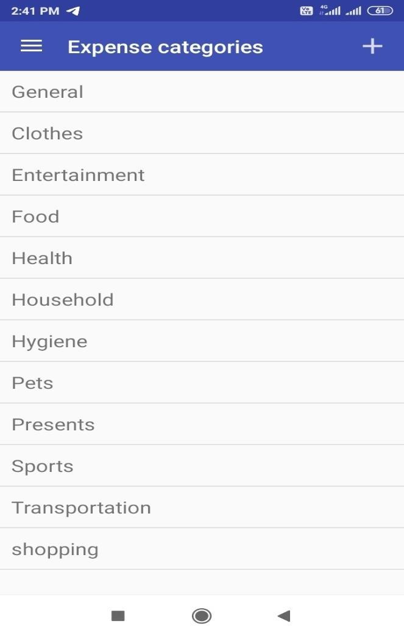
- Category_list_item.xml

<?xml version="1.0" encoding="utf-8"?>
<RelativeLayout xmlns:android="http://schemas.android.com/apk/res/android" android:layout_width="match_parent" android:layout_height="wrap_content" >

<TextView android:id="@+id/category_name_list_item" android:layout_width="match_parent" android:layout_height="wrap_content" android:layout_alignParentLeft="true" android:layout_alignParentStart="true" android:padding="10dp" android:textSize="19sp" />

EXPENSE TRACER

</RelativeLayout>

CategoryEditActivity.java

package com.github.ematiyuk.expensetracer.activities;

import android.os.Bundle;
import android.support.annotation.Nullable;
import android.support.v7.app.ActionBar;

import com.github.ematiyuk.expensetracer.fragments.CategoryEditFragment;

public class CategoryEditActivity extends BaseFragmentActivity {

/* Important: use onCreate(Bundle savedInstanceState)
* instead of onCreate(Bundle savedInstanceState, PersistableBundle persistentState) */
@Override
protected void onCreate(@Nullable Bundle savedInstanceState) {
super.onCreate(savedInstanceState);

insertFragment(new CategoryEditFragment()); setupActionBar();
}

private void setupActionBar() {
ActionBar actionBar = getSupportActionBar();
if (actionBar != null) {
// Show the Up button in the action bar (toolbar).
actionBar.setDisplayHomeAsUpEnabled(true);
}
}
}

EXPENSE TRACER

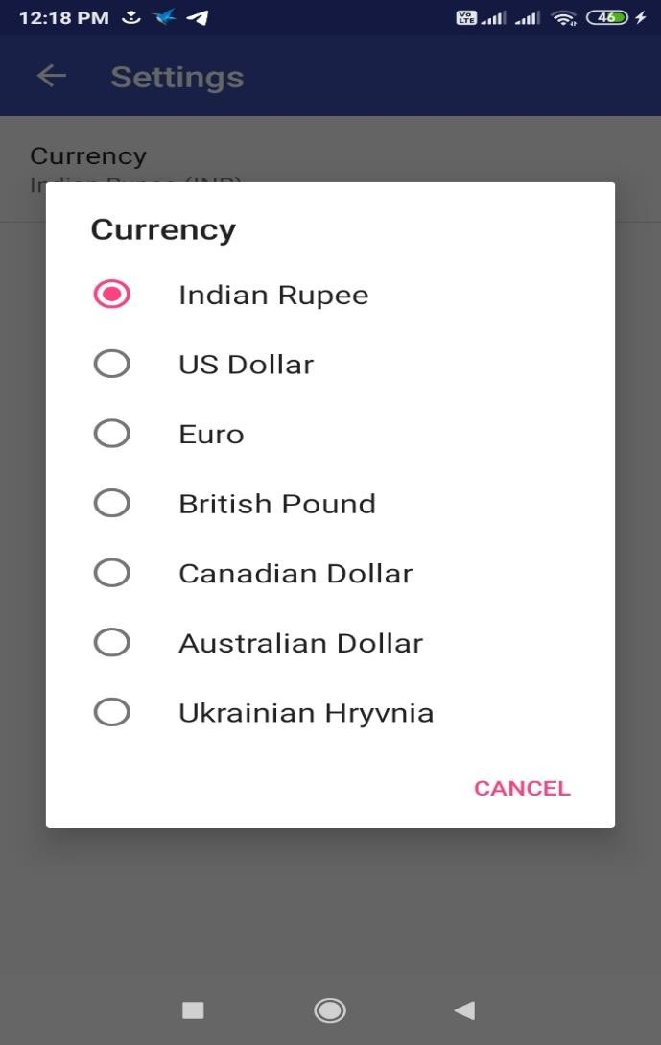
SettingsActivity.java

package com.github.ematiyuk.expensetracer.activities;

import android.os.Bundle;
import android.support.annotation.Nullable;
import android.support.v7.app.ActionBar;

import com.github.ematiyuk.expensetracer.R;
import com.github.ematiyuk.expensetracer.fragments.SettingsFragment;
public class SettingsActivity extends BaseFragmentActivity { @Override

EXPENSE TRACER

protected void onCreate(@Nullable Bundle savedInstanceState) {
super.onCreate(savedInstanceState); insertFragment(new SettingsFragment());

setTitle(R.string.nav_settings);

setupActionBar();
}

private void setupActionBar() {
ActionBar actionBar = getSupportActionBar();
if (actionBar != null) {
// Show the Up button in the action bar (toolbar).
actionBar.setDisplayHomeAsUpEnabled(true);
}
}
}

BaseFragmentActivity.java

package com.github.ematiyuk.expensetracer.activities;

import android.os.Bundle;
import android.support.annotation.LayoutRes; import android.support.annotation.Nullable; import android.support.v4.app.Fragment;
import android.support.v4.app.FragmentManager; import android.support.v7.app.AppCompatActivity; import android.support.v7.widget.Toolbar;

import com.github.ematiyuk.expensetracer.R;

public abstract class BaseFragmentActivity extends AppCompatActivity {
protected Toolbar mToolbar;

@LayoutRes
protected int getLayoutResId() {
return R.layout.activity_base;
}

EXPENSE TRACER

@Override
protected void onCreate(@Nullable Bundle savedInstanceState) { super.onCreate(savedInstanceState); setContentView(getLayoutResId());

// Set a Toolbar to replace the ActionBar
mToolbar = (Toolbar) findViewById(R.id.toolbar); setSupportActionBar(mToolbar);
}

protected void insertFragment(Fragment fragment) {
// Insert the fragment by replacing any existing fragment FragmentManager fragmentManager = getSupportFragmentManager(); fragmentManager.beginTransaction()
.replace(R.id.content_frame, fragment)
.commit();
}
}

String.xml

<resources>
<string name="app_name">ExpenseTracer</string>

<string name="nav_today">Today</string>
<string name="nav_report">Expense reports</string>
<string name="nav_categories">Expense categories</string>
<string name="nav_settings">Settings</string>

<string name="drawer_open">Open navigation drawer</string>
<string name="drawer_close">Close navigation drawer</string>

<string name="add_category">Add a category</string>
<string name="edit_category">Edit category</string>
<string name="delete_category">Delete category</string>
<string name="delete_cat_dialog_msg">All associated expenses will be deleted as well. Are you sure you want to delete the category?</string>
<string name="category_deleted">Category deleted</string>
<string name="category_added">Category added</string>
<string name="category_updated">Category updated</string>

EXPENSE TRACER

<string name="category_name_string">Category name</string>

<string name="today_total">Today\'s total</string>
<string name="today_expenses">Today\'s expenses</string>

<string name="add_expense">New expense</string>
<string name="edit_expense">Edit expense</string>
<string name="delete_expense">Delete expense</string>
<string name="delete_exp_dialog_msg">Are you sure you want to delete the expense?</string>
<string name="expense_deleted">Expense deleted</string>
<string name="expense_added">Expense added</string>
<string name="expense_updated">Expense updated</string>
<string name="expense_category_name_string">Category</string>

<plurals name="expenses_deleted_plurals_msg">
<item quantity="one">%d expense deleted</item>
<item quantity="other">%d expenses deleted</item>
</plurals>

<string name="delete_string">Delete</string>
<string name="done_string">Done</string>
<string name="error_empty_field">Empty field</string>
<string name="error_zero_value">Zero value is invalid</string>
<string name="error_incorrect_input">Incorrect input</string>

<string name="filter_expenses">Filter</string>
<string name="filter_option_today">By Today</string>
<string name="filter_option_week">By Week</string>
<string name="filter_option_month">By Month</string>
<string name="filter_option_date">By Date</string>
<string name="filter_option_range">By Date range</string>
<string name="filter_todays_expenses">Today\'s expenses</string>
<string name="filter_weeks_expenses">Week\'s expenses</string>
<string name="filter_months_expenses">Month\'s expenses</string>
<string name="filter_date_expenses">For %s</string>
<string name="filter_date_range_expenses">%1$s - %2$s</string>

<string name="default_string">Default</string>
<string name="no_categories_string">&#60;No categories&#62;</string>
<string name="no_expenses">There are no expenses.</string>
<string name="total_string">Total</string>

EXPENSE TRACER

<string name="pref_currency_title">Currency</string>

<string name="pref_currency_default">USD</string>
<string-array name="pref_currency_list_titles">
<item>Indian Rupee</item>
<item>US Dollar</item>
<item>Euro</item>
<item>British Pound</item>
<item>Canadian Dollar</item>
<item>Australian Dollar</item>
<item>Ukrainian Hryvnia</item>

</string-array>
<string-array name="pref_currency_list_values">
<item>INR</item>
<item>USD</item>
<item>EUR</item>
<item>GBP</item>
<item>CAD</item>
<item>AUD</item>
<item>UAH</item>

</string-array>

<!-- Predefined expense categories -->
<string name="cat_general">General</string>
<string name="cat_clothes">Clothes</string>
<string name="cat_entertainment">Entertainment</string>
<string name="cat_food">Food</string>
<string name="cat_health">Health</string>
<string name="cat_household">Household</string>
<string name="cat_hygiene">Hygiene</string>
<string name="cat_pets">Pets</string>
<string name="cat_presents">Presents</string>
<string name="cat_sports">Sports</string>
<string name="cat_transportation">Transportation</string>

</resources>

- SectionExpenseAdapter
package com.github.ematiyuk.expensetracer.adapters;

EXPENSE TRACER

import android.content.Context; import android.database.Cursor; import android.view.View; import android.view.ViewGroup; import android.widget.TextView;


import com.github.ematiyuk.expensetracer.R;
import com.github.ematiyuk.expensetracer.providers.ExpensesContract;
import com.github.ematiyuk.expensetracer.utils.Utils;
import com.twotoasters.sectioncursoradapter.SectionCursorAdapter;

public class SectionExpenseAdapter extends SectionCursorAdapter {
private String mCurrency;

public SectionExpenseAdapter(Context context) {
super(context, null, 0);
}

public void setCurrency(String currency) { mCurrency = currency; notifyDataSetChanged();
}

@Override
protected Object getSectionFromCursor(Cursor cursor) { String dateStr =
cursor.getString(cursor.getColumnIndexOrThrow(ExpensesContract.Expenses.DATE));
return Utils.getSystemFormatDateString(mContext, dateStr);
}

@Override
protected View newSectionView(Context context, Object item, ViewGroup parent) {
return getLayoutInflater().inflate(R.layout.expense_report_section_header, parent, false);
}

@Override
protected void bindSectionView(View convertView, Context context, int position, Object item) {
((TextView) convertView).setText((String) item);
}

EXPENSE TRACER

@Override
protected View newItemView(Context context, Cursor cursor, ViewGroup parent) {
return getLayoutInflater().inflate(R.layout.expense_list_item, parent, false);
}


@Override
protected void bindItemView(View convertView, Context context, Cursor cursor) {
// Find fields to populate in inflated template
TextView tvExpenseValue = (TextView) convertView.findViewById(R.id.expense_value_text_view);
TextView tvExpenseCurrency = (TextView) convertView.findViewById(R.id.expense_currency_text_view);
TextView tvExpenseCatName = (TextView) convertView.findViewById(R.id.expense_category_name_text_view);

// Extract values from cursor
float expValue = cursor.getFloat(cursor.getColumnIndexOrThrow(ExpensesContract.Expenses.VALUE));
String categoryName = cursor.getString(cursor.getColumnIndexOrThrow(ExpensesContract.Categories.NAME));

// Populate views with extracted values tvExpenseValue.setText(Utils.formatToCurrency(expValue)); tvExpenseCatName.setText(categoryName); tvExpenseCurrency.setText(mCurrency);
}
}

SimpleExpenseAdapter

package com.github.ematiyuk.expensetracer.adapters;

import android.content.Context;
import android.database.Cursor;
import android.support.v4.widget.CursorAdapter;
import android.view.LayoutInflater;
import android.view.View; import android.view.ViewGroup; import android.widget.TextView;

import com.github.ematiyuk.expensetracer.providers.ExpensesContract;

EXPENSE TRACER

import com.github.ematiyuk.expensetracer.R;
import com.github.ematiyuk.expensetracer.utils.Utils;

public class SimpleExpenseAdapter extends CursorAdapter {
private String mCurrency;


public SimpleExpenseAdapter(Context context) {
super(context, null, 0);
}

public void setCurrency(String currency) { mCurrency = currency; notifyDataSetChanged();
}

// The newView method is used to inflate a new view and return it
@Override
public View newView(Context context, Cursor cursor, ViewGroup parent) {
return LayoutInflater.from(context).inflate(R.layout.expense_list_item, parent, false);
}

// The bindView method is used to bind all data to a given view
@Override
public void bindView(View view, Context context, Cursor cursor) {
// Find fields to populate in inflated template
TextView tvExpenseValue = (TextView) view.findViewById(R.id.expense_value_text_view);
TextView tvExpenseCurrency = (TextView) view.findViewById(R.id.expense_currency_text_view);
TextView tvExpenseCatName = (TextView) view.findViewById(R.id.expense_category_name_text_view);

// Extract values from cursor
float expValue = cursor.getFloat(cursor.getColumnIndexOrThrow(ExpensesContract.Expenses.VALUE));
String categoryName = cursor.getString(cursor.getColumnIndexOrThrow(ExpensesContract.Categories.NAME));

// Populate views with extracted values tvExpenseValue.setText(Utils.formatToCurrency(expValue)); tvExpenseCatName.setText(categoryName);

EXPENSE TRACER

tvExpenseCurrency.setText(mCurrency);
}
}


ExpenseDbHelper

package com.github.ematiyuk.expensetracer.db;

import android.content.ContentValues;
import android.content.Context;
import android.database.sqlite.SQLiteDatabase;
import android.database.sqlite.SQLiteOpenHelper;

import com.github.ematiyuk.expensetracer.R;
import com.github.ematiyuk.expensetracer.providers.ExpensesContract.Categories;
import com.github.ematiyuk.expensetracer.providers.ExpensesContract.Expenses;

public class ExpenseDbHelper extends SQLiteOpenHelper {
private static final int DATABASE_VERSION = 1;
private static final String DATABASE_NAME = "expense_tracer.db";

public static final String CATEGORIES_TABLE_NAME = "categories"; public static final String EXPENSES_TABLE_NAME = "expenses";

private Context mContext;

public ExpenseDbHelper(Context ctx) {
super(ctx, DATABASE_NAME, null, DATABASE_VERSION);
mContext = ctx;
}

@Override
public void onCreate(SQLiteDatabase db) { db.execSQL(CategoriesTable.CREATE_TABLE_QUERY);
// Fill the table with predefined values
CategoriesTable.fillTable(db, mContext);

db.execSQL(ExpensesTable.CREATE_TABLE_QUERY);
}

@Override

EXPENSE TRACER

public void onUpgrade(SQLiteDatabase db, int oldVersion, int newVersion) {
/* Temporary (dummy) upgrade policy */ db.execSQL(ExpensesTable.DELETE_TABLE_QUERY); db.execSQL(CategoriesTable.DELETE_TABLE_QUERY); onCreate(db);

}

private static final class CategoriesTable {
public static final String CREATE_TABLE_QUERY =
"CREATE TABLE " + CATEGORIES_TABLE_NAME + " (" + Categories._ID + " INTEGER PRIMARY KEY AUTOINCREMENT, " + Categories.NAME + " TEXT NOT NULL);";

public static final String DELETE_TABLE_QUERY =
"DROP TABLE IF EXISTS " + CATEGORIES_TABLE_NAME + ";";

public static void fillTable(SQLiteDatabase db, Context ctx) { String[] predefinedNames =
ctx.getResources().getStringArray(R.array.predefined_categories); ContentValues values = new ContentValues();
for (String name : predefinedNames) { values.put(Categories.NAME, name); db.insert(CATEGORIES_TABLE_NAME, null, values);
}
}
}

private static final class ExpensesTable {
public static final String CREATE_TABLE_QUERY =
"CREATE TABLE " + EXPENSES_TABLE_NAME + " (" + Expenses._ID + " INTEGER PRIMARY KEY AUTOINCREMENT, " + Expenses.VALUE + " FLOAT NOT NULL, " +
Expenses.DATE + " DATE NOT NULL, " + Expenses.CATEGORY_ID + " INTEGER NOT NULL);";

public static final String DELETE_TABLE_QUERY =
"DROP TABLE IF EXISTS " + EXPENSES_TABLE_NAME + ";";
}
}

EXPENSE TRACER

REFERENCES

Web Links:
- www.google.com
- www.wikipedia.com
- draw.io

